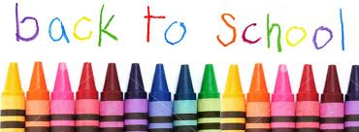

*English and Immersion list
Dear Students, Parents and Families,
Welcome to Grade One! This is an exciting time of year where we learn many new words, become better readers and learn how to add and subtract! Below is a list of school supplies. We cannot wait to meet each and every one of you in September!
Supplies
- Change of clothes (pants, shirt, underwear, socks) labeled and bagged.
- 1 pair of indoor sneakers (Velcro)
- 1 box of Kleenex
- 1 package of page protectors
- $45.00 for remaining school supplies (your child’s teacher will provide duotangs, pencils, erasers, markers, crayons, scissors, journals, art supplies, etc.)
- 1 package of dry erase markers
- 1 package of large ziplock bags
- 1 package of small ziplock bags
- Due to the possibility of school closures next year we encourage you to have a set of essential school supplies for home. Suggested items are pencils, crayons, markers, scissors, glue, erasers, and art supplies.
ASD-W’s preferred form of payment is through Cashless. You are able to register – a simple task that takes less than 2 minutes by visiting https://www.schoolcashonline.com/ or visiting our website at http://web1.nbed.nb.ca/sites/ASD-W/NMES/Pages/default.aspx and navigating your way to the School Cash Online on the right hand side of the screen.
Have a wonderful summer, see you soon!
The Grade One Teachers

